**STOCK MARKET PREDICTION**

Stock and stock markets have always been investment jargon to me. To learn about the whole system works, starting from defining important terms, learning to interpret stock charts, learning some of the stock markets in place, I have challenged myself to use this guided project by [Dataquest](https://youtu.be/1O_BenficgE?si=YTeirvt0wlinNKIw) to learn as much as I can.

The objectives for this project include:

📖 To get a basic idea of how stock markets work.

📈 To use machine learning to predict stock market patterns.

# **Introduction**

## *Fundamental Concepts*

### **What are stocks?**

Stocks, also called equity, are a security representing ownership of a part of the issuing corporation.

Units of stocks are called shares. A person who has shares in an organization is entitled to a proportion of the organization’s assets and profits equivalent to how much stock the own.

### **How are stocks traded?**

Stocks are bought and sold predominantly in stock exchanges. Corporations issue stock to raise funds to operate their businesses.

Shareholders(holders of stock) are considered owners of the issuing company depending on the number of shares owned relative to the number of [outstanding shares](https://www.investopedia.com/terms/o/outstandingshares.asp).

For example, if an Wayne Enterprises has 200 shares of stock outstanding, and Clark Kent owns 20 shares, he owns and has a claim to 10% of the company’s assets and earnings.

An interesting concept is the *“separation of ownership and control”*. What shareholders own are shares issued by the corporation, and the corporation owns the assets held by a firm. When you own 25 % of the shares a company, you don’t necessarily own one-quarter of the company. However, you do own one-quarter of the company’s shares.

A stock exchange is a marketplace where stocks,[bonds](https://en.wikipedia.org/wiki/Bond_(finance)), and other [securities](https://www.investopedia.com/terms/s/security.asp) are bought and sold.

Functions of stock exchanges:

* Serve as a forum for buying and selling securities
* Ensures that there is plenty of capital, in turn enabling the broader stock market to function efficiently
* Provides real-time pricing information to investors so that they can make informed decisions.

Shares of stock become available on an exchange after a company conducts its initial public offering (IPO). A company sells shares to an initial set of public shareholders in an IPO known as the primary market. After the IPO floats shares into the hands of public shareholders, these shares can be sold and purchased on an exchange or the secondary market.

A stock market refers to several exchanges where shares of publicly held companies are bought and sold. It is an umbrella term representing all stocks that trade in a particular region or country, and is often represented as an index or grouping of various stocks, such as the S&P 500.

Key Players at a Stock Exchange

* **Brokers:** are individuals or firms that represent the interest of outside investors at a stock exchange.
* **Dealers**: are individuals or firms that buy and sell securities for themselves.
* **Broker-dealers:** firms that performs/plays the combined roles of brokers and dealers.
* **Market makers:** these are mainly dealers that buy and sell stocks for their own benefit specifically to provide liquidity to a stock exchange as a whole.

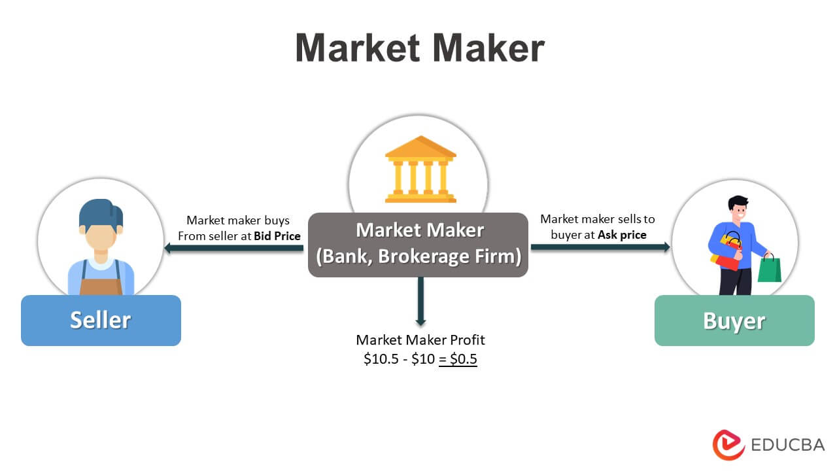

[Image Source](https://www.google.com/url?sa=i&url=https%3A%2F%2Fwww.educba.com%2Fmarket-maker%2F&psig=AOvVaw0xdGPPF75uPKHte1mUvDSX&ust=1709289885939000&source=images&cd=vfe&opi=89978449&ved=2ahUKEwjbrYOVr9CEAxVWRaQEHQPjBdoQr4kDegUIARCEAQ)

### **Types of stocks**

The two main types of stock are *common* and *preferred* stock.

* **Common Stock:** The owner is entitled to vote at shareholders’ meetings, and can receive dividends paid out by the corporation.
* **Preferred Stock:** The owners don’t have voting rights. However, they have a higher claim on assets and payments than common shareholders. They can receive dividends before common shareholders and are given priority when a company goes bankrupt and is liquidated.

Here is a table showing comparison of the two:

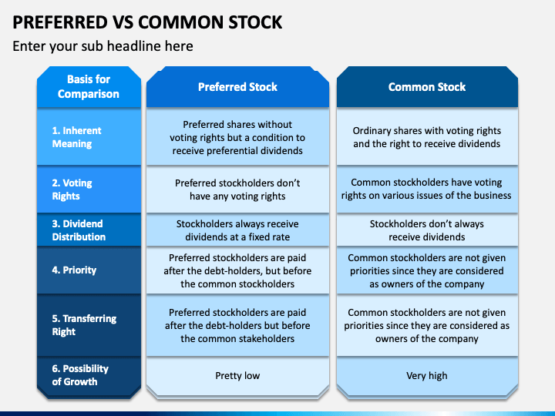

[Image Source](https://www.google.com/url?sa=i&url=https%3A%2F%2Fwww.sketchbubble.com%2Fen%2Fpresentation-preferred-vs-common-stock.html&psig=AOvVaw109NxrhAkvKUDY-5agfIQ2&ust=1709289659269000&source=images&cd=vfe&opi=89978449&ved=0CBUQjhxqFwoTCKiMvamu0IQDFQAAAAAdAAAAABAc)

Beyond the two main categories, there are other types of stock that depend on the nature of the company, and they include growth stocks, value stocks, dividend stocks, and Blue-chip stocks.

### **Investment strategies**

Investment strategies refer to a set of principles that help an investor meet their financial and investment goals. The strategies can be conservative(low-risk and focused on wealth protection) or aggressive(seeking rapid growth and focused on capital appreciation).

Strategies depend on factors such as age, goals, lifestyles,financial situations, risk tolerance, available capital, and expected returns.

Value investing, Index investing and Growth investing are some of the investment strategies in place.

* **Value investing:** simply means an investor buying stock from companies that the marketplace has undervalued. Value investors typically buy into strong companies that are trading at low prices that an investor believes don’t reflect the company’s true value.
* **Growth investing:** involves investing in stocks based on the intrinsic value of a company and it’s potential to grow in the future. Growth investors mainly focus on young companies that have shown potential for significant growth. The general theory behind growth investing is that the growth in earnings or revenue a company generates will then be reflected by an increase in share prices.
* **Index investing:** is a passive investment strategy that seeks to replicate the returns of a benchmark index. This [Youtube video](https://www.youtube.com/watch?v=r2mATkslxa8) manages to dumb down the concept of index funds and index investing.

### **How stock prices are determined**

A company’s total market value,it’s market capitalization or market cap, is determined by multiplying its stock price by the number of shares outstanding. As a result, any significant change in stock price results in an equal percentage change in the company’s market cap.

Supply and demand forces greatly influence stock prices. If demand for a limited number of shares outpaces the supply, then the stock price normally rises. And if the supply is greater than demand, the stock price typically falls.

A continuous rise in prices is known as an uptrend, and a continuous drop in prices in called a downtrend. Sustained uptrends form a "bull" market and sustained downtrends are called "bear" markets.

*⚠ Market capitalization is an inadequate way to value a company because its market price is not necessarily a reflection of how much a piece of the business is worth. Shares are often over- or undervalued by the market.*

### **Factors that influence stock prices**

* **Inflation**

Inflation is the increase in cost of goods ans services, reducing the buying power of businesses and consumers. If the rate of inflation increases, investors tend to sell their stocks and vice versa. In other words, inflation is positively correlated to stock prices and activity

* **State of the economy**

Key economic indicators such as GDP growth, unemployment rates, inflation rates, and consumer confidence can influence stock prices. Positive economic data often leads to higher stock prices as it indicates a healthy economy.

* **Company Activity**

Specific events related to a company, such as product launches, mergers and acquisitions, management changes, or legal issues, can impact its stock price.

* **News**

The news could be new information or old information unearthed. News has a significant impact on investor sentiment and their decisions to buy or sell stocks. Good news will affect investor sentiment positively while bad news cause the opposite.

* **Market Sentiment**

Market sentiment is the collective attitude of investors towards a particular market or security. Factors such as news, rumors, and investor perceptions about a company or the overall market can drive buying or selling activity.

* **Interest rates**

Interest rates play a huge part in how much it costs companies to borrow money. If interest rates are high, that could bump up corporate borrowing expenses. As a result, corporate earnings could suffer, causing stock prices as a whole to dip. Furthermore, higher interest rates might make stocks less attractive than certificates of deposit (CDs), bonds and other investments whose yields benefit from higher interest rates.

* **Consumer spending**

A healthy level of consumer spending can lift sales and earnings, and subsequently share prices, for a whole host of publicly traded companies. By the same token, weakness in consumer spending can put a dent in corporate sales, earnings, and stock prices.

* **World events**

Geopolitical events, such as wars, political instability, trade tensions, and natural disasters, can have a significant impact on stock prices, especially in global markets.

## *Interpreting stock charts*

A stock chart is a graphical representation of how a stock’s price or trading volumes have changed over time.

Stock charts have two axis, the vertical axis and the horizontal axis. The horizontal axis represents the historical time periods for which a technical chart has been constructed. The vertical axis displays the stock price or the trading volume corresponding to each period.

### **Types of charts used**

The four most common types of charts used for technical analysis are line charts, bar charts, points and figure charts, and candlestick chart.

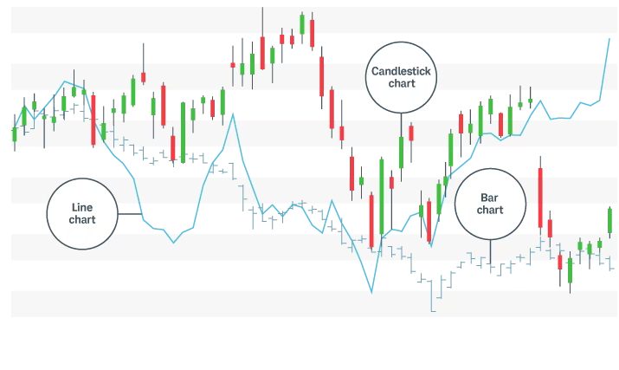

[Image Source](https://www.schwab.com/learn/story/how-to-read-stock-charts-and-trading-patterns)

* **Line chart**

It plots a single line that connects all the closing prices of a stock for a certain time interval. This representation method has some value when correlating a stock's trend or overall performance to the market without being too concerned about intra-day fluctuations.

* **Bar chart**

Bar charts help traders see the price range of each period. Bars may increase or decrease in size from one bar to the next or over a range of bars. Notice how the bars expand and contract between periods of high and low volatility. As the market becomes increasingly volatile, the bars become larger and the price swings further. As the market becomes quieter, price typically contracts into smaller bars.

The vertical height of the bar reflects the range between the high and low price of the bar period. The price bar also records the period's opening and closing prices with attached horizontal lines; the left line represents the open, and the right line represents the close.

* **Candlestick chart**

This is a variation of the bar chart. Candles help visualize bullish or bearish sentiment by displaying distinctive "bodies" that are green or red, depending on whether the stock closes higher or lower than the open. The body represents the range between the opening and closing prices of the time intervals; the high and low prices are called the wick or shadow.

In a normal bull market, there might be more clusters of green candles than red candles, while the reverse is true for a bear market.

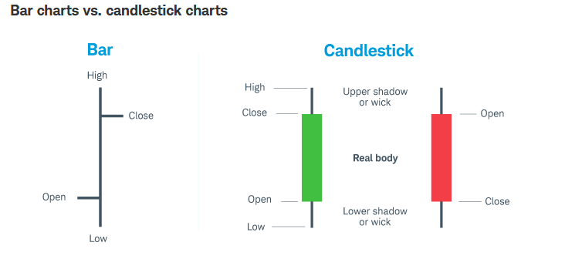

[Image Source](https://www.schwab.com/learn/story/how-to-read-stock-charts-and-trading-patterns)

This [Investopedia article](https://www.investopedia.com/articles/technical/112601.asp) thoroughly covers how to interpret stock chart patterns.

## *Stock markets in place*

### **Major Stock Exchanges**

The [top 10 largest stock exchanges in the world by market capitalization](https://scripbox.com/pf/largest-stock-exchanges-in-the-world/) are:

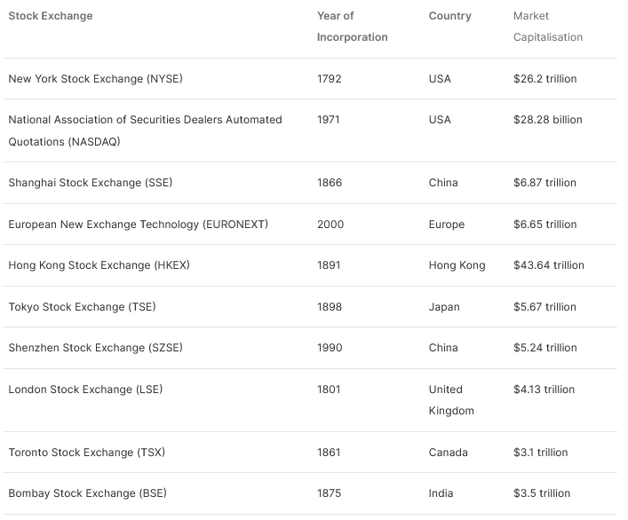

An additional helpful read on the same can be found [here.](https://www.linkedin.com/pulse/10-largest-stock-exchanges-world-market-capitalization)

### **Primary markets vs Secondary markets**

Primary market, also known as “new issue market”, is where new securities are issued and sold for the first time by companies or governments to raise capital. It direct transactions between the issuer and the investor. The primary market serves the purpose of capital formation, allowing companies and governments to raise funds for various purposes.

An initial public offering, or IPO, is an example of a primary market.

Secondary market, is where investors trade previously issued securities without the issuing companies' involvement. Imagine you want to purchase shares of a popular tech company like XYZ Inc. (XYZ). When you buy XYZ stock, you're essentially engaging in a transaction with another investor who already owns shares of XYZ. XYZ Inc. itself isn't directly participating in this specific transaction.

### **Stock Market Indexes**

A stock market index/stock index measures a section of the stock market. It tracks the performance of a certain group of stocks. There is no set size when it comes to market indexes.

Each stock market index has it’s own formula of determining which companies or investments to include. Once an index manager has determined which companies to include, they then need to know how those companies are represented in the index. This involves a factor called index weighting. The weighting determines what impact the companies have in the index’s performance.

Common weighting models include:

* **Market-cap Weighted:**the index dominantly represents stocks with higher market capitalization. Large companies have a bigger impact on the index’s performance.
* **Equal Weighted:** all companies in the index are treated the same, meaning the individual company performance all affect the index by the same amount, regardless of the company size.
* **Price Weighted:** the weight granted to company depends on its current share price. Larger share prices have more weight in the indexes, regardless of the size of the company.

Common Stock Market Indexes

* **The S&P 500 Index:** tracks performance of top 500 U.S companies determined by a company known as S&P Dow Jones Indices. It is a market-cap weighed index.
* **The Nasdaq 100:** tracks the performance of 100 of the largest and actively traded stocks in the Nasdaq stock exchange. It uses market-cap weighting model.
* **Dow Jones Industrial Average (DJIA):** tracks just 30 U.S companies as selected by S&P Dow Jones Indices. These stocks come from a range of industries but are all blue chip stocks( have a history of strong financial performance). It is a price weighted index.
* **The NYSE Composite Index**: tracks the performance of all stocks traded on the New York Stack Exchange(NYSE). It is a market-cap weighed index.
* **The Russell 2000 Index:** measures the performance of 2,000 of the smallest publicly traded domestic companies. It is also a market-cap weighed index.

In the spirit of patriotism 😂, I will also feature the Kenya’s stock index

* **Nairobi Securities Exchange All Share Index(NSE-ASI):** it tracks performance of all listed companies on the Nairobi Stock Exchange (NSE). It is also a market-capitalization weighed index.

# **Source of Data**

The data used in the project was sourced from the Yahoo Finance API using a python module known as yfinance.

Yahoo Finance:

yfinance :

# **New coding concepts learnt in this project**

### **Shifting a column**

I have a never needed to shift a column till now. Shifting columns refers to moving the column values up and down by a certain number of rows.This can be done using pandas’ shift() function.

The function only takes one argument.If the argument is positive, the value are shifted downwards meaning the top cell in the column will be null. If the argument is negative, the values are shifted upwards and as a result, the last cell in that column will be null.

The argument determines the number of rows the column will be shifted by for example shift(2), shifts the values downwards by 2 rows.

### **Dropping a column using del method**

I have always used the drop method to drop columns in a data frame. I learnt an easier method to do it using a del function,which deletes the column.

The syntax is **del dataframe[”Column name”]**

# **Reference Links**

## Introduction References:

* <https://youtu.be/1O_BenficgE?si=YTeirvt0wlinNKIw>
* <https://www.investopedia.com/terms/s/stock.asp>
* <https://www.investopedia.com/articles/investing/082614/how-stock-market-works.asp>
* <https://www.forbes.com/advisor/investing/how-stock-trading-works/>
* <https://www.investopedia.com/articles/basics/04/092404.asp>
* <https://www.investopedia.com/terms/i/investmentstrategy.asp>
* <https://corporatefinanceinstitute.com/resources/career-map/sell-side/capital-markets/stock-investment-strategies/>
* <https://time.com/personal-finance/article/how-are-stock-prices-determined/>
* <https://www.forbes.com/advisor/investing/stock-market-index/>

## Sources of data References:

* <https://medium.com/@kasperjuunge/yfinance-10-ways-to-get-stock-data-with-python-6677f49e8282>

## New Coding concepts Learnt References: